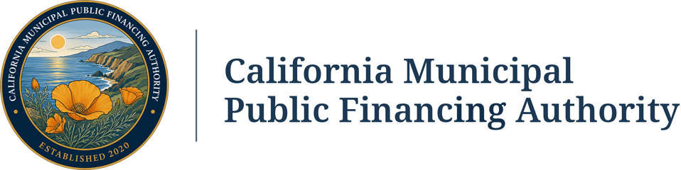
NON-CHARTER MEMBERSHIP AGREEMENT
by and between the
CALIFORNIA MUNICIPAL PUBLIC FINANCING AUTHORITY
and the
______________________________
This NON-CHARTER MEMBERSHIP AGREEMENT, dated as of ____________ __, 20___, is by and between THE CALIFORNIA MUNICIPAL PUBLIC FINANCING AUTHORITY (“CalMuni PFA”) and the ______________________________, a duly organized public agency, validly existing under the laws of the State of California (the “Agency”);
W I T N E S S E T H:
WHEREAS, certain public agencies of the State of California (collectively, the “Charter Members”) have entered into a Joint Powers Agreement Creating the California Municipal Public Financing Authority (the “Agreement”), establishing CalMuni PFA and prescribing its purposes and powers, and providing, among other things, for qualifying public agencies to become non-charter members of CalMuni PFA (each a “Non-Charter Member”); and
WHEREAS, CalMuni PFA has been formed for the purpose, among others, of exercising any powers common to the Charter and Non-Charter Members, including but not limited to acquiring, constructing, improving, operating, leasing and disposing of real property for a public purpose, all as specified in the Agreement, and to exercise the additional powers granted to it in the Act (as defined in the Agreement) and any other applicable provisions of the laws of the State of California; and
WHEREAS, CalMuni PFA has been established pursuant to the Agreement and the Act and is empowered to issue or execute non-recourse debt, which may include bonds, notes, commercial paper or any other evidences of indebtedness, leases, installment sale or other financing agreements or certificates of participation therein (herein “Obligations”), and to otherwise undertake financing programs under the Act or other applicable provisions of the laws of the State of California to accomplish its public purposes; and
WHEREAS, the Agency desires to become a Non-Charter Member of CalMuni PFA; and
WHEREAS, the Board of Directors of CalMuni PFA (the “Board”) has determined that the Agency should become a Non-Charter Member of CalMuni PFA; and
NOW, THEREFORE, in consideration of the above premises and of the mutual promises herein contained, CalMuni PFA and the Agency do hereby agree as follows:
Section 1. Non-Charter Member Status. The Agency is hereby made a Non-Charter Member of CalMuni PFA for all purposes of the Agreement and the Bylaws of CalMuni PFA, the provisions of which are hereby incorporated herein by this reference. From and after the date of execution and delivery of this Non-Charter Membership Agreement by the Agency and CalMuni PFA, the Agency shall be and remain a Non-Charter Member of CalMuni PFA.
Section 2. Restrictions and Rights of the Agency. The Agency shall not have the right, as a Non-Charter Member of CalMuni PFA, to vote on any action taken by the Board. In addition, no officer, employee or representative of the Agency shall have any right to become an officer or director of CalMuni PFA by virtue of this Non-Charter Membership Agreement.
Section 3. Effect of Prior Actions. The Agency hereby agrees to be subject to and bound by all actions previously taken by the Board to the same extent as the Members of CalMuni PFA are subject to and bound by such actions.
Section 4. No Obligations of the Agency. The debts, liabilities and obligations of CalMuni PFA shall not be the debts, liabilities and obligations of the Agency.
Section 5. Execution of this Non-Charter Membership Agreement. Execution of this Non-Charter Membership Agreement shall satisfy the requirements of Section 12 of the Agreement and Article VI of the Bylaws of CalMuni PFA for participation by the Agency in all programs and other undertakings of CalMuni PFA, including, without limitation, any undertaking to finance the acquisition, construction, installation and/or equipping of public capital improvements, and any other financing program undertaken by CalMuni PFA.
Section 6. Withdrawal. The Agency may withdraw as a Non-Charter Member upon written notice to CalMuni PFA at any time when none of the following remain outstanding: (a) any Obligations issued or entered into by CalMuni PFA for the benefit of the Agency, or any agreement of the Agency relating to such Obligations; or (b) any Obligations issued by CalMuni PFA to finance projects within the Agency’s jurisdiction with the Agency’s consent or approval, including Obligations secured by assessments or special taxes levied within the Agency’s jurisdiction. While any such Obligation or agreement remains outstanding, the Agency may not withdraw and shall remain a Non-Charter Member until all such Obligations have been paid or discharged in full.
IN WITNESS WHEREOF, the parties hereto have caused this Non-Charter Membership Agreement to be executed by their proper officers thereunto duly authorized, on the day and year first set forth above.
CALIFORNIA MUNICIPAL PUBLIC FINANCING AUTHORITY
By: ______________________________
Name: ____________________________
Title: _____________________________
[NAME OF AGENCY]
By: ______________________________
Name: ____________________________
Title: _____________________________

